Elizabeth Coon_{α/2}
MATH 1040
Part II
Confidence Interval Estimates
A confidence interval is a range of values used to estimate the true value of a population parameter, such as mean, proportion, and standard deviation. It uses a confidence level, expressed as a percentage, to identify the degree of confidence that the interval actually contains the population parameter. This in found by using a critical value, which is the number used to separate the sample statistics that are likely to occur from those that are unlikely to occur.
Each population parameter uses a different method for conducting a confidence interval:
Proportion (ƿ) | E = z_{α/2} (√pq/n) | E = error margin  Z_{α/2} = critical value for z-distribution  p = sample proportion  q = 1 – p  n = sample size
Mean (µ) | When σ is not known:  E = t_{α/2} (s/√n)  When σ is known:  E = z_{α/2} (σ/√n) | t_{α/2} = critical value for t-distribution
Standard Deviation (σ) | √[(n-1)s²/ χ ²_{R}] < σ < √[(n-1)s²/ χ ²_{L}] | s² = variance (and sample standard deviation squared)  χ ²_{R} = right tail critical value of Chi-Square distribution  χ ²_{L} = left tail critical value of Chi-Square distribution

In our class, we used Skittles bags to display a sample statistics for calculating the population parameters for Skittles of the same sized bag (2.17 oz). Tables A-2, A-3, and A-4 from the textbook were used to find critical values and their associated probabilities. Here is our classes sample information:
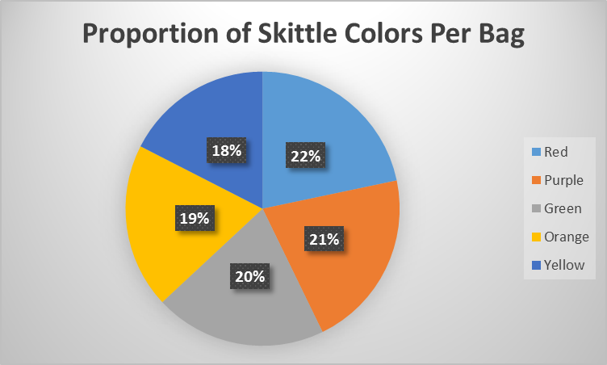
Total: 1470
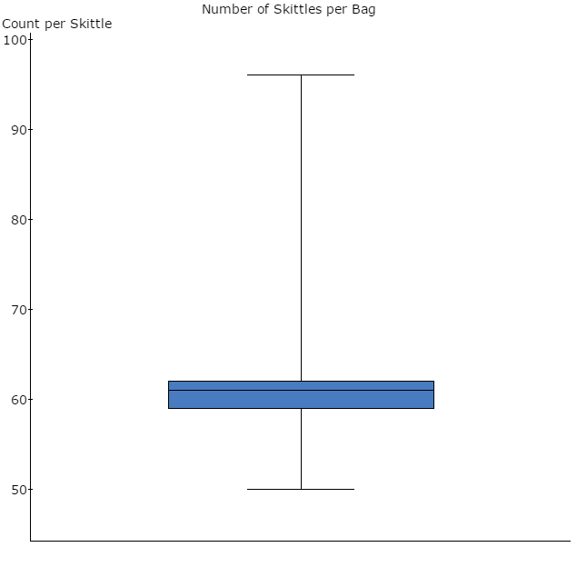
Candies Per Bag
Sample size (n) is 24 students
Mean (ẋ) is 61.3 candies
Standard deviation (s) 7.94 candies
Construct a 99% confidence interval estimate for the true proportion of yellow candies.
Proportion of yellow candies (p): 0.18  99% confidence level: α = .01  q = 0.82  n = 1470  z_{α/2} = 2.575 | E = z_{α/2} (√pq/n)  E = 2.575 [√(0.18*0.82/1470)]  E = 2.575 (0.01002)  E = 0.0258 | Left interval:  p – E = 0.18 – 0.0258 = 0.1542  Right interval:  p + E = 0.18 + 0.0258 = 0.2058

I am 99% confident that the true proportion of all yellow candies in a 2.17 oz bag of Skittles is between 15.42% and 20.58%.
Construct a 95% confidence interval estimate for the true mean number of candies per bag.
Sample Mean (ẋ) = 61.3  Sample size (n) = 24  Standard deviation (s) = 7.94  95% confidence level: α = .05  Degrees of freedom = n – 1 = 23  t_{α/2} = 2.069 | When σ is not known:  E = t_{α/2} (s/√n)  E = 2.069 (7.94/√24)  E = 2.069 (1.6207)  E = 3.3533 | Left interval:  ẋ - E = 61.3 – 3.3533 = 57.6467  Right interval:  ẋ + E = 61.3 + 3.3533 = 64.6533

I am 95% confident that the true mean number of candies in all 2.17 oz bags of Skittles is between 58 and 65 candies, which is rounded to the nearest whole number because you cannot have half a candy. The candy piece is either present or not.
Construct a 98% confidence interval estimate for the standard deviation of the number of candies per bag.
s = 7.94  n = 24  Degrees of freedom = 23  98% confidence level: α = .02  χ ²_{R} = 41.638  χ ²_{L} = 10.196 | √[(n-1)s²/ χ ²_{R}]  √[(24-1)7.94²/ 41.638]  √34.824 = 5.9012  √[(n-1)s²/ χ ²_{L}]  √[(24-1)7.94²/ 10.196]  √142.213 = 11.9253 | √[(n-1)s²/ χ ²_{R}] < σ < √[(n-1)s²/ χ ²_{L}]  5.9012 < σ < 11.9253

I am 98% confident that the true standard deviation of the number of candies per all 2.17 oz Skittles bags are between 5.9012 and 11.9253.
Hypothesis Tests
A hypothesis test is a procedure for testing a claim (or hypothesis) about a parameter of a population. First, you identify the null hypothesis (H₀), which is the original claim held by nature, or previous studies. Second, you identify the alternative hypothesis (H₁) that differs from the H₀. Next, you determine your significance level (α), which is the probability that the test statistic, or critical value, will fall in the critical region when the hypothesis is actually true. This number is found by subtracting the confidence level proportion by 1 (i.e. a 95% confidence level has α = 0.05). Then you compare the test statistic to the significance level. If the test statistic is less than or equal to the significance level, you may reject the H₀. If the test statistic is greater than the significance level, you fail to reject H₀. Finally, you can make an inference about your null hypothesis on whether is supports the true population, or doesn’t.
Each population parameter uses a different method for conducting a hypothesis test statistic:
Proportion (P) | z = (p – P) / √(PQ/n)  Q = 1 – P
Mean (µ)  When σ is not known | t = (ẋ - µ) / (s/√n)  ẋ = sample mean
Mean (µ)  When σ is known | z = (ẋ - µ) / (σ/√n)
Standard Deviation (σ) | χ ² = (n-1)s² / σ²

Use a 0.05 significance level to test the claim that 20% of all Skittles candies are red.
H₀: P = 0.20  H₁: P ≠ 0.20  p = 0.22  Q = 1 – P = 0.80  n = 1470  α = 0.05 | z = (p – P) / √(PQ/n)  z = (0.22 – 0.2) / √(0.2*0.8/1470)  z = 0.02 / 0.010433  z = 1.92  p-value = 0.0548 | p-value vs α  0.0548 > 0.05  Fail to reject H₀

There is not sufficient evidence to reject the claim that 20% of all Skittles candies are red in all 2.7 oz Skittles bags.
Use a 0.01 significance level to test the claim that the mean number of candies in a bag of Skittles is 55.
H₀: µ = 55  H₁: µ ≠ 55  ẋ = 61.3  s = 7.94  n = 24  degrees freedom = 23  α = .01 | When σ is not known:  t = (ẋ - µ) / (s/√n)  t = (61.3- 55) / (7.094/√24)  t = 6.3 / 1.4481  t = 3.8871  p-value = 0.0007 | p-value vs α  0.0007 < 0.01  Reject H₀

There is sufficient evidence to reject the claim that the mean number of candies in all 2.7 oz bags of Skittles is 55.
Reflection
In order to make the confidence interval estimates and the hypothesis test certain conditions must be met that abide by the Central Limit Theorem. They require that the population is a normal distribution or the sample size is larger than 30. Our proportion of yellow skittles has a sample size of 1470 so it meets the criteria. However, the mean and standard deviation of candies per bag only have a sample size of 25, which means it fails to meet the required criteria for an accurate confidence interval estimate and hypothesis test. This suggests that our estimate might not have accurately captured the mean and standard deviation. It also suggests that our hypothesis test of the mean number of Skittles could have fallen into the Type 1 Error where we reject a claim that is actually true.
In order to improve our results of capturing a more accurate confidence interval estimate and hypothesis test, we must draw a larger simple random sample. It order to satisfy the Central Limit Theorem, we need a sample size of at least 30 bags of Skittles.
Through our sample statistics, I was able to infer parameters of all 2.17 oz bags of Skittles. Our sample gave the true proportion of all yellow candies in a 2.17 oz bag of Skittles is between 15.42% and 20.58% with 99% confidence. Also it showed the true mean number of candies in all 2.17 oz bags of Skittles is between 58 and 65 candies with 95% confidence, and the true standard deviation is between 5.9012 and 11.9253 with a 9 confidence. I was also able to test claims through our sample statistics. There is not sufficient evidence to reject the claim that 20% of all Skittles candies are red in all 2.7 oz Skittles bags. However, there is sufficient evidence to reject the claim that the mean number of candies in all 2.7 oz bags of Skittles is 55. These inferences were made with the thought in mind that the sample doesn’t meet the criteria for the Central Limit Theorem, unless the population is a normal distribution.

